Case Study: 6
Title: To study and implement basic string operations using html,css, js.
Software/Tools Required: VSC, HTML, CSS, JavaScript
Case Study program code:
index.html:
<!DOCTYPE html>
<html lang="en">
<head>
<meta charset="UTF-8">
<meta name="viewport" content="width=device-width, initial-scale=1.0">
<title>String Operations using JavaScript</title>

<link rel="stylesheet" href="style.css">
</head>

<body>

<div class="container">

<h1>JavaScript String Operations</h1>

<!-- Basic String Operations -->
<section>
<h2>1. Basic String Operations</h2>

<input type="text" id="basicString"
placeholder="Enter a string">

<button onclick="performBasicOperations()">
Perform Operations
</button>

<div id="basicOutput" class="output"></div>
</section>

<!-- String Methods -->
<section>
<h2>2. String Methods</h2>

<input type="text" id="methodString"
placeholder="Enter a string">

<input type="text" id="searchText"
placeholder="Text to search">

<input type="text" id="replaceText"
placeholder="Text to replace">

<input type="text" id="replacement"
placeholder="Replacement text">

<button onclick="performStringMethods()">
Apply Methods
</button>

<div id="methodOutput" class="output"></div>
</section>

<!-- Reverse String -->
<section>
<h2>3.Reverse a String</h2>

<input type="text" id="reverseInput"
placeholder="Enter a string">

<button onclick="reverseString()">
Reverse
</button>

<div id="reverseOutput" class="output"></div>
</section>

<!-- Count Vowels -->
<section>
<h2>4. Count Vowels</h2>

<textarea id="paragraphInput"
placeholder="Enter a paragraph"></textarea>

<button onclick="countVowels()">
Count Vowels
</button>

<div id="vowelOutput" class="output"></div>
</section>

</div>

<script src="script.js"></script>

</body>
</html>

Script.js:
// 1. Basic String Operations

function performBasicOperations() {

let str = document.getElementById("basicString").value;

if (str === "") {
document.getElementById("basicOutput").innerHTML =
"Please enter a string.";
return;
}

let output = `
<strong>Original String:</strong> ${str}<br>
<strong>Length:</strong> ${str.length}<br>
<strong>Uppercase:</strong> ${str.toUpperCase()}<br>
<strong>Lowercase:</strong> ${str.toLowerCase()}<br>
<strong>First Character:</strong> ${str.charAt(0)}
`;

document.getElementById("basicOutput").innerHTML = output;
}

// 2. String Methods
// substring(), indexOf(), split(), replace()

function performStringMethods() {

let str = document.getElementById("methodString").value;
let search = document.getElementById("searchText").value;
let replaceText = document.getElementById("replaceText").value;
let replacement = document.getElementById("replacement").value;

if (str === "") {
document.getElementById("methodOutput").innerHTML =
"Please enter a string.";
return;
}

let substringResult = str.substring(0, 5);

let indexResult = search !== ""
? str.indexOf(search)
: "Enter text to search";

let splitResult = str.split(" ").join(" | ");

let replaceResult = replaceText !== ""
? str.replace(replaceText, replacement)
: "Enter text to replace";

let output = `
<strong>substring(0, 5):</strong> ${substringResult}<br>
<strong>indexOf():</strong> ${indexResult}<br>
<strong>split():</strong> ${splitResult}<br>
<strong>replace():</strong> ${replaceResult}
`;

document.getElementById("methodOutput").innerHTML = output;
}

// 3. Case Study: Reverse a String

function reverseString() {

let str = document.getElementById("reverseInput").value;

if (str === "") {
document.getElementById("reverseOutput").innerHTML =
"Please enter a string.";
return;
}

let reversed = str.split("").reverse().join("");

document.getElementById("reverseOutput").innerHTML =
`<strong>Reversed String:</strong> ${reversed}`;
}

// 4. Case Study: Count Vowels in a Paragraph

function countVowels() {

let paragraph = document.getElementById("paragraphInput").value;

if (paragraph === "") {
document.getElementById("vowelOutput").innerHTML =
"Please enter a paragraph.";
return;
}

let count = 0;

for (let character of paragraph.toLowerCase()) {

if ("aeiou".includes(character)) {
count++;
}
}

document.getElementById("vowelOutput").innerHTML =
`<strong>Number of Vowels:</strong> ${count}`;
}
Style.css:
* {
box-sizing: border-box;
margin: 0;
padding: 0;
}

body {
font-family: Arial, sans-serif;
background-color: #f4f6f8;
padding: 30px;
}

.container {
max-width: 900px;
margin: auto;
}

h1 {
text-align: center;
margin-bottom: 30px;
}

section {
background-color: white;
padding: 25px;
margin-bottom: 25px;
border-radius: 10px;
box-shadow: 0 2px 8px rgba(0, 0, 0, 0.1);
}

h2 {
margin-bottom: 15px;
}

input,
textarea {
width: 100%;
padding: 12px;
margin: 8px 0;
border: 1px solid #ccc;
border-radius: 5px;
font-size: 15px;
}

textarea {
height: 120px;
resize: vertical;
}

button {
padding: 12px 20px;
margin-top: 10px;
border: none;
border-radius: 5px;
cursor: pointer;
font-size: 15px;
background-color: #333;
color: white;
}

button:hover {
background-color: #555;
}

.output {
margin-top: 15px;
padding: 15px;
background-color: #f1f1f1;
border-radius: 5px;
line-height: 1.8;
}
Output:
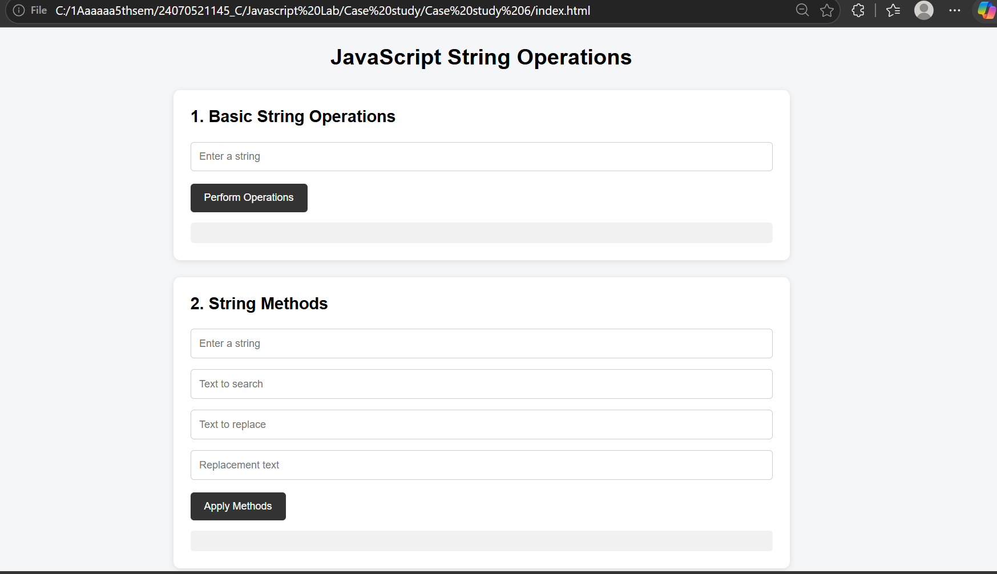
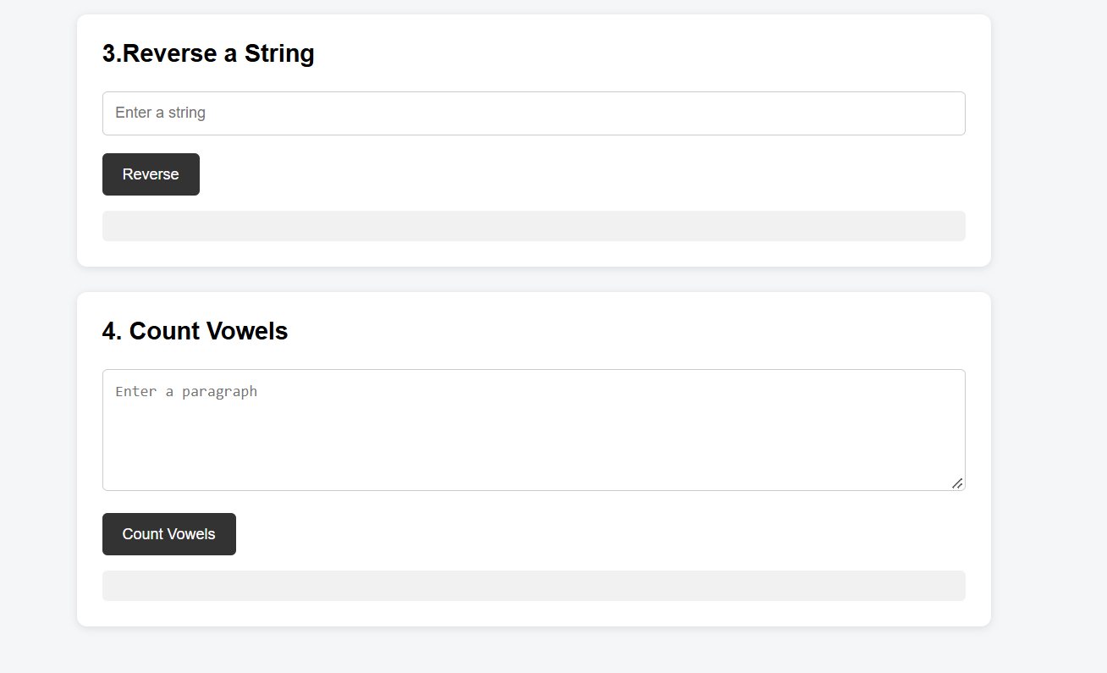

RESULT
The experiment was successfully performed and the concepts of JavaScript and basic string operations were performed.

